4.1.

Create a Birthday Card app

1.Introduction

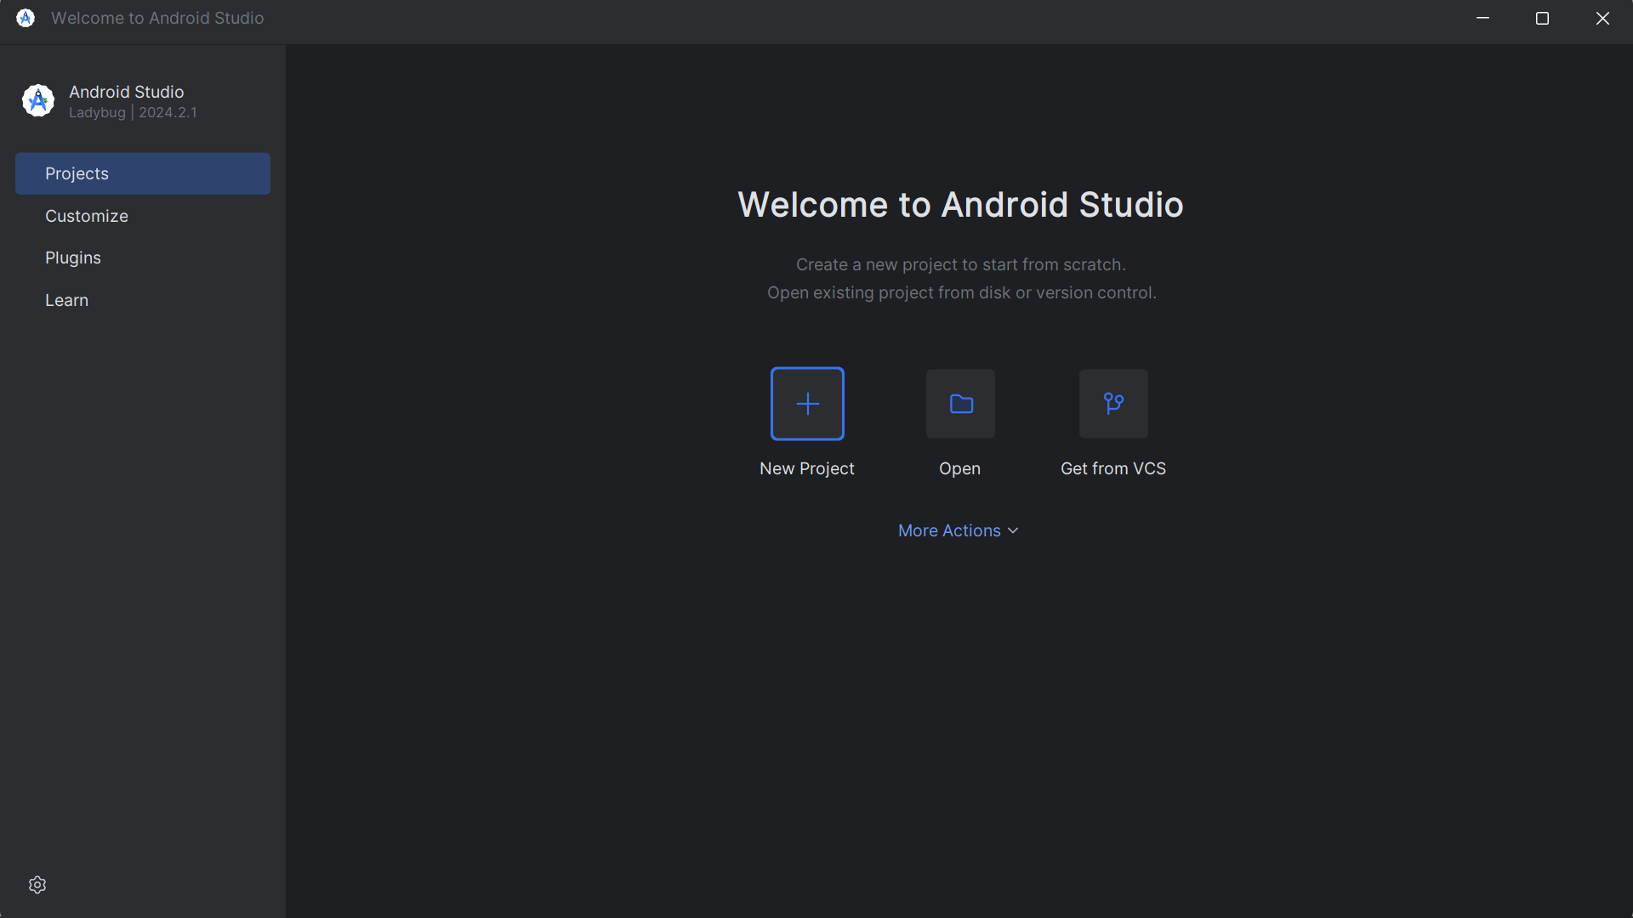

2. Set up your Happy Birthday app

3.Add Textview to the layout

4.Add style to the text

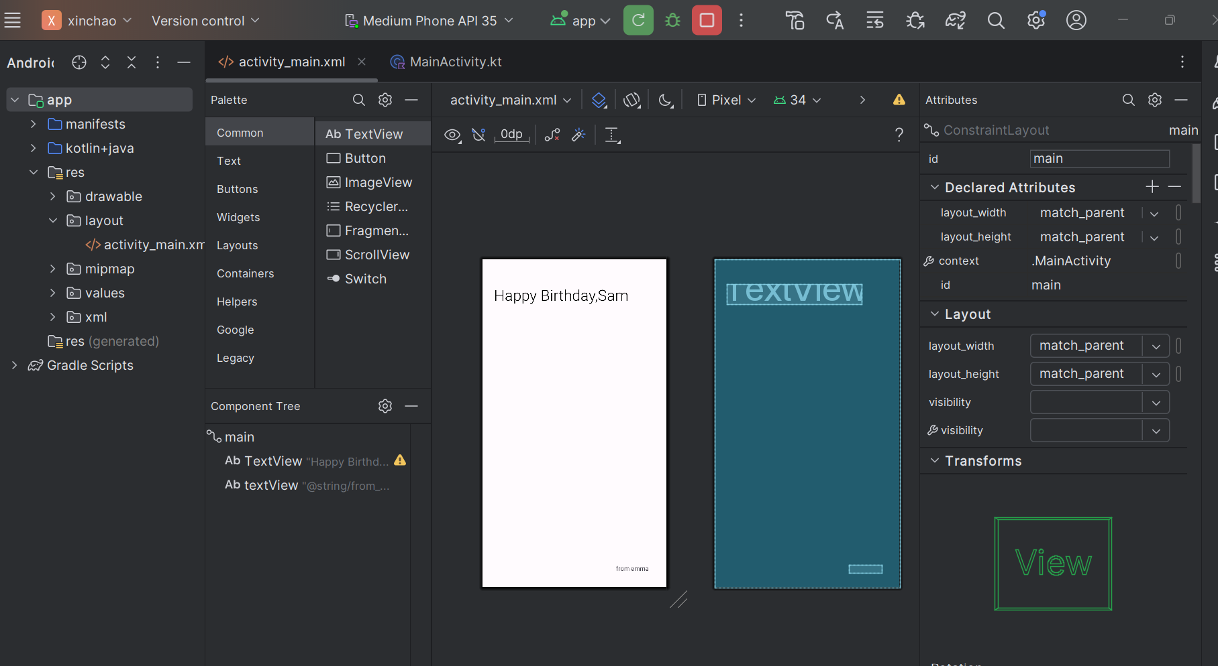

5.Solution

6. Summary

• The Layout Editor helps you create the UI for your Android app.

• Almost everything you see on the screen of your app is a View.

• A TextView is a UI element for displaying text in your app.

• A ConstraintLayout is a container for other UI elements.

• Views need to be constrained horizontally and vertically within a ConstraintLayout.

• One way to position a View is with a margin.

• A margin says how far a View is from an edge of the container it's in.

• You can set attributes on a TextView like the font, text size, and color.

7. Learn more

• Vocabulary for Android Basics in Kotlin

• View

• TextView

• ConstraintLayout

• dp vs. sp

• Layout Editor in Android Studio